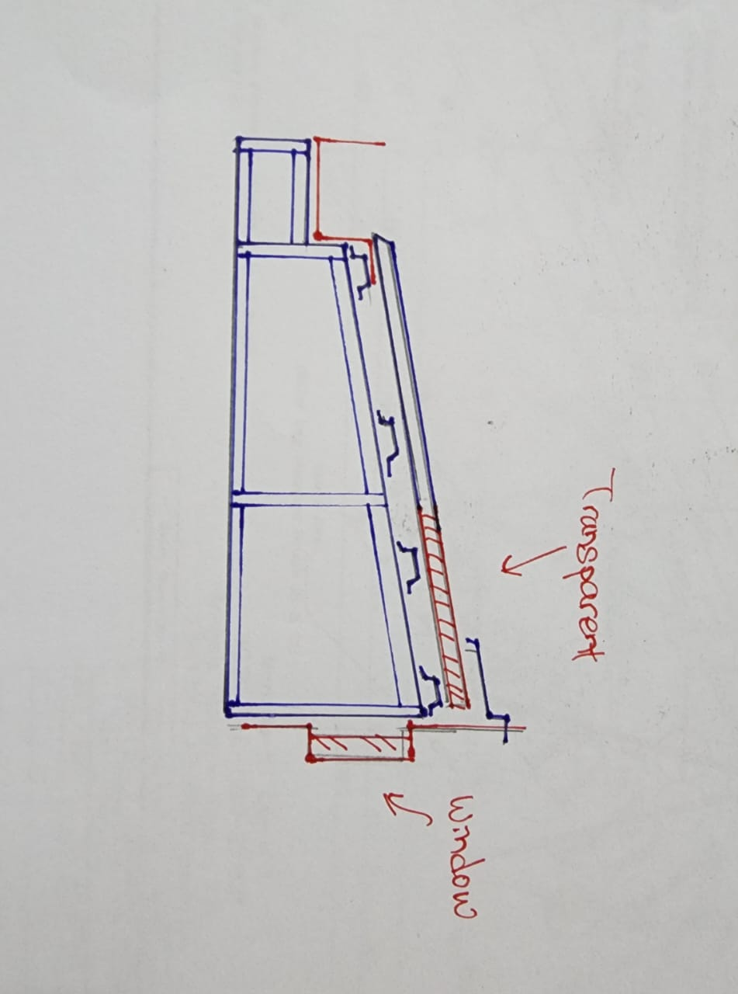
PROPOSAL FOR METAL DECK ROOF

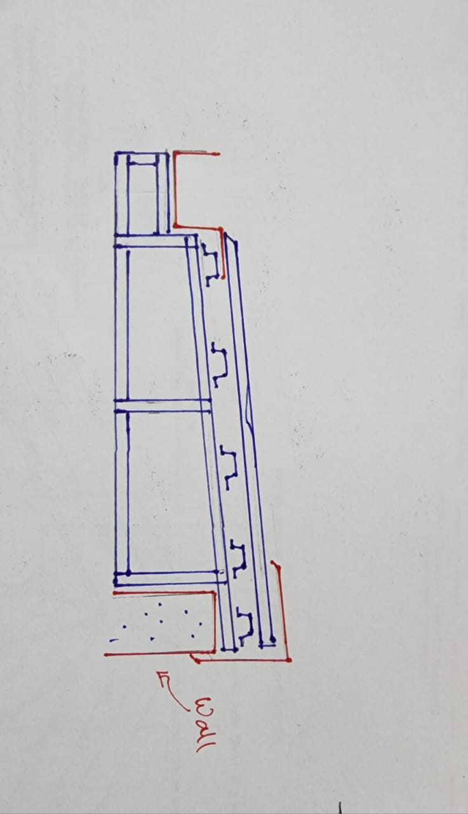
PROPOSAL FOR METAL DECK ROOF (Window Area)

